SUNDAY REVIEW|
Swallowed by the Sea

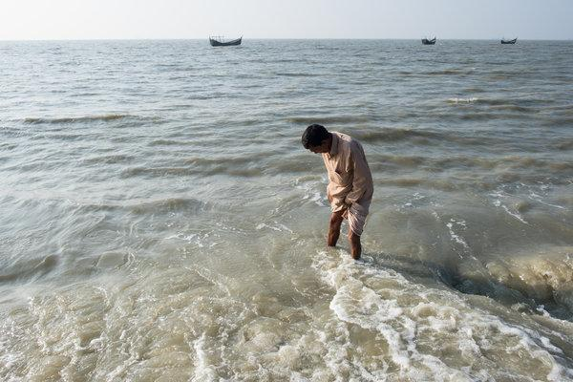
Zainal Abedin stands near the spot where remnants of his family home on the Bangladeshi island of Kutubdia sit underwater.Credit Thomas Nybo/Redux, for Unicef
Opinion
You doubt climate change? Come to this island — but hurry, before it disappears.
By Nicholas Kristof
- Jan. 19, 2018

  - 321
Leer en español
KUTUBDIA, Bangladesh — Anyone who doubts climate change should come to this lovely low-lying island, lapped by gentle waves and home to about 100,000 people.
But come quickly, while it’s still here.
“My house was over there,” said Zainal Abedin, a farmer, pointing to the waves about 100 feet from the shore. “At low tide, we can still see signs of our house.”
Already much of Kutubdia has been swallowed by rising seas, leaving countless families with nothing. Nurul Haque, a farmer who lost all his land to the ocean, told me that he may have to pull his daughter, Munni Akter, 13, out of eighth grade and marry her off to an older man looking for a second or third wife, because he has few financial options left to support her.
“I DON’T REALLY WANT TO MARRY HER OFF, BECAUSE IT’S NOT GOOD FOR GIRLS,” HE SAID GLUMLY. “BUT I’M CONSIDERING IT.” HE INSISTED THAT IF IT WEREN’T FOR THE RISING WATERS AND HIS RESULTING IMPOVERISHMENT, HE WOULDN’T THINK OF FINDING A HUSBAND FOR HER.

Image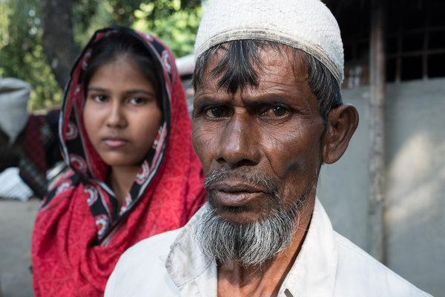
Nurul Haque, a farmer whose land was consumed by the ocean, is considering marrying off his 13-year-old daughter, Munni Akter, because he’s running out of ways to support her.CreditThomas Nybo/Redux, for Unicef
One of the paradoxes of climate change is that the world’s poorest and most vulnerable people — who contribute almost nothing to warming the planet — end up being most harmed by it.
Bangladesh is expected to be particularly badly hit by rising oceans because much of the country is only a few feet above sea level.
“Climate change is destroying children’s futures,” noted Justin Forsyth, the deputy executive director of Unicef. “In Bangladesh, tens of millions of children and families are at risk of losing their homes, their land and their livelihoods from rising sea levels, flooding and increased cyclone intensity.”
Forsyth said the average Bangladeshi produces just one-tenth of the global average in annual per-capita carbon emissions. In contrast, the United States accounts for more than one-quarter of cumulative carbon emissions since 1850, more than twice as much as any other country.
If Munni is pulled out of school and married off, she’ll have plenty of company. Unicef data suggest that 22 percent of girls in Bangladesh marry by the age of 15, one of the highest rates in the world.
“Climate changes appear to be increasing the numbers of girls who are forced to marry,” a three-year academic study in Bangladesh concluded.
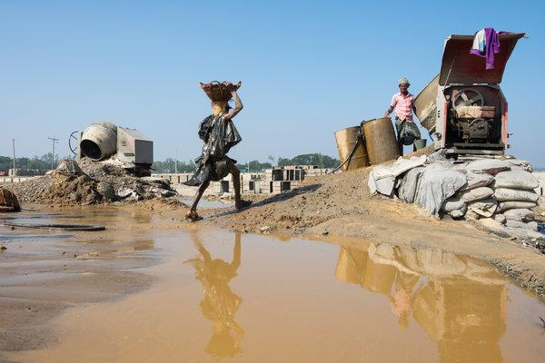
Image
On the mainland, gravel is carried to cement mixers, to be used in concrete blocks that will be placed along the coast to hold back the rising sea.CreditThomas Nybo/Redux, for Unicef
A year ago in Madagascar I met a family ready to marry off a 10-year-old girl, Fombasoa, because of a drought linked to climate change. And there are increasing reports that poverty linked to climate change is leading to child marriage in Malawi, Mozambique and other countries.
In Kutubdia, climate change is not the only issue. The seas are rising, but in addition, Kutubdia itself seems to be sinking.
The upshot is that the island’s shoreline has retreated by about a kilometer since the 1960s, farmers say. Even when land is mostly dry, occasional high tides or storm surges bring in saltwater that poisons the rice paddies. Thousands of climate refugees have already fled Kutubdia and formed their own neighborhood in the mainland Bangladeshi city of Cox’s Bazaar.
A similar injustice is apparent in many poor countries. “Climate change contributes to conflict,” noted Neal Keny-Guyer, the C.E.O. of Mercy Corps, the aid group. He observed that a drier climate is widely believed to have caused agricultural failures, tensions and migrations that played a role in the Syrian civil war, the Darfur genocide and the civil war in northeastern Nigeria.
On the mainland, gravel is carried to cement mixers, to be used in concrete blocks that will be placed along the coast to hold back the rising sea.CreditThomas Nybo/Redux, for Unicef
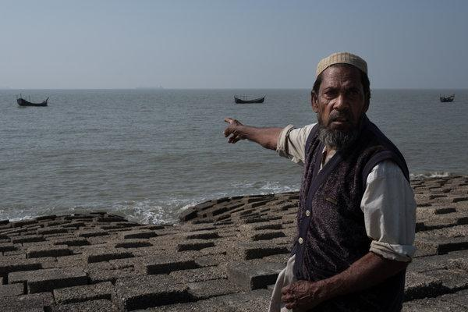

Aside from reducing carbon emissions, Keny-Guyer said, Western countries can do much more to build resilience in poor countries. That can include supporting drought-resistant or saltwater-resistant crops, and offering microinsurance to farmers and herdsmen so that a drought does not devastate them. Mercy Corps is now developing such microinsurance.
The evidence of climate change is increasingly sobering, with the last four years also the hottest four years on record since modern record-keeping began in the 1880s.
We’re also coming to understand that climate change may wreak havoc, changing ocean currents, killing coral reefs and nurturing feedback loops that accelerate the warming. It turns out that 99 percent of green sea turtles hatched in the northern Great Barrier Reef are now female because their sex is determined by temperature.
Most of the villagers I spoke to both in Madagascar and in Bangladesh had never heard of President Trump. But the outlook for their descendants may depend on the actions he takes — and his withdrawal from the Paris climate accord is an unhelpful surrender of American leadership.
Americans were recently horrified by a viral video of a starving polar bear, whose condition may or may not be linked to climate change. Let’s hope we can be just as indignant about the impact of climate change on children like Munni.

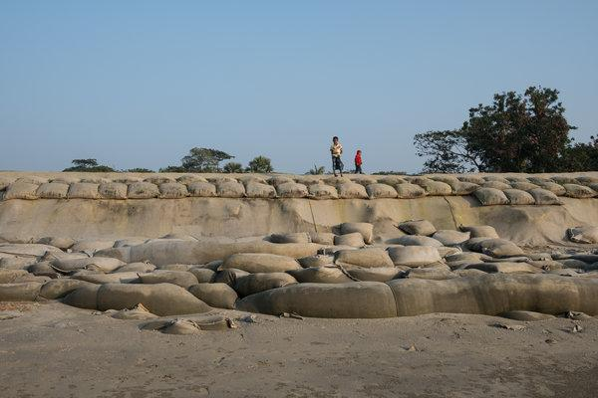
Structures were recently added along the island’s coastline in an attempt to prevent the further encroachment of the ocean.CreditThomas Nybo/Redux, for Unicef
I invite you to sign up for my free, twice-weekly email newsletter. Please also join me on Facebook and Google+, watch my YouTube videos and follow me on Twitter (@NickKristof).
A version of this article appears in print on Jan. 21, 2018, on Page SR11 of the New York edition with the headline: Come to This Island, Before It Disappears. Order Reprints | Today’s Paper | Subscribe
READ 321 COMMENTS

